Point to Site VPN setup for Ayana

VPN Setup Path- C:\Macmet
Server Name- MTL-RDPSRV01
Server IP- : 172.16.1.4

- Double Click on MEIClient Certifiacte.pfx
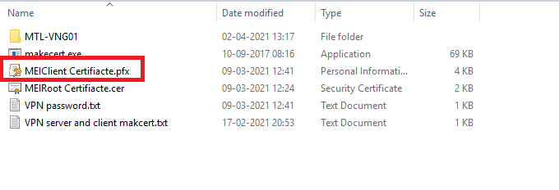
- Select Current User click on Next
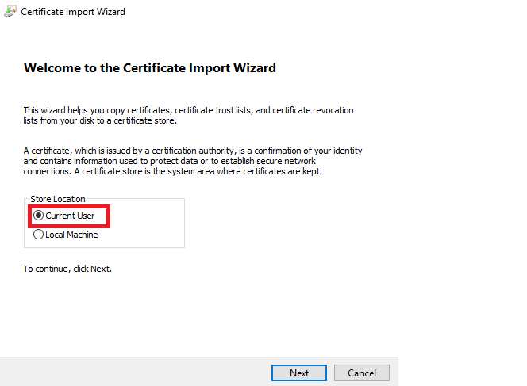

- Specify the file you want to Import. Click on Next
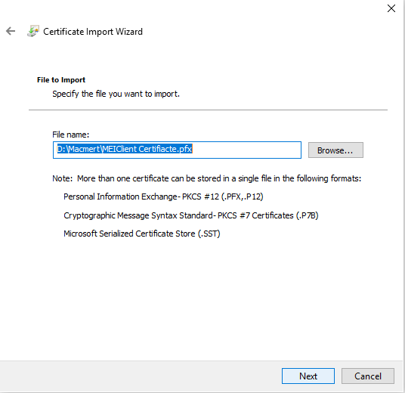

- Type the password- 12345 Click on Next
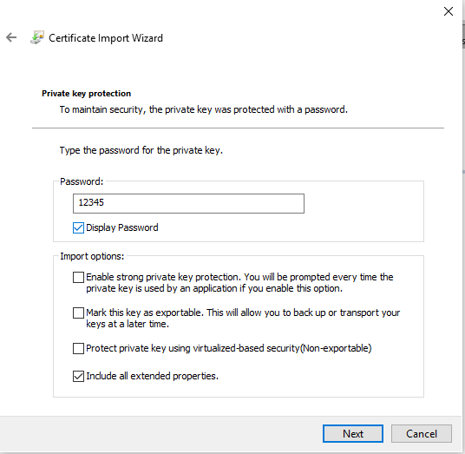

- Click on Automatically select the certificate store based on the type of certificate
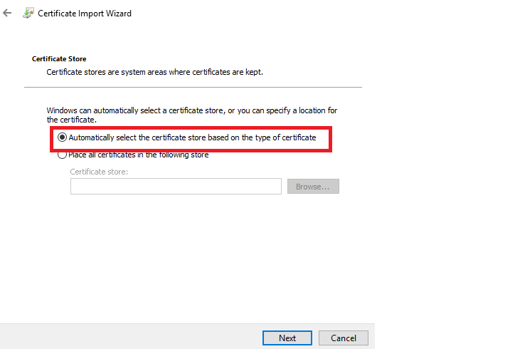

- Click on Yes
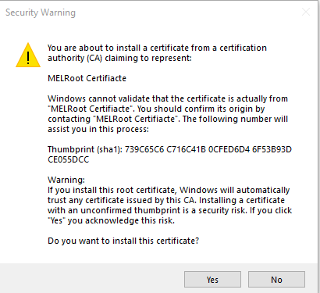

- Click on OK
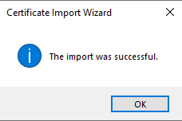

- Install MEIRoot Certiacte and Install Certificate

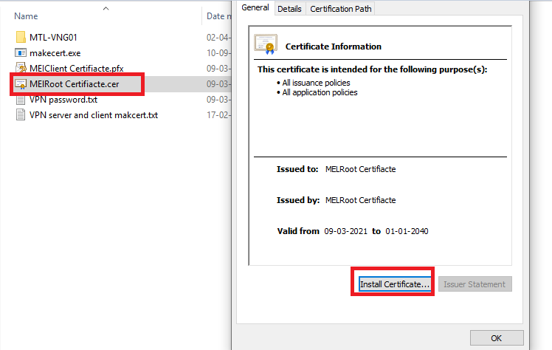

- Click on Next
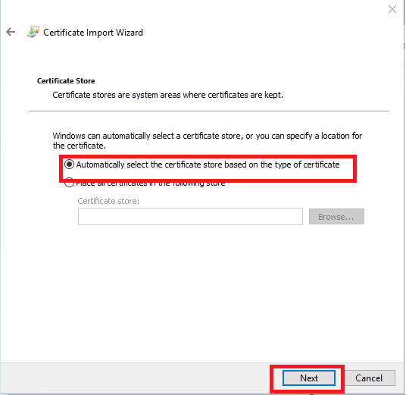

- Click on Finish
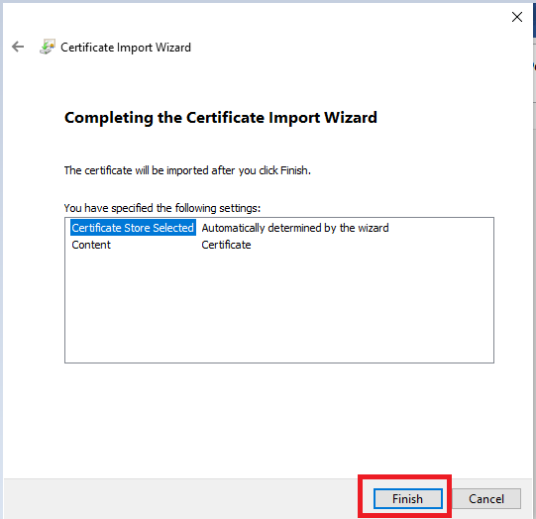

- Install VpnClientSetupAmd64 (Check the OS Configuration. if 32bit you can Install VPNClientSetupX86)

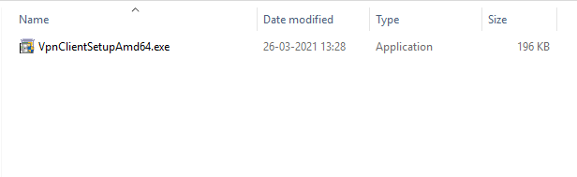

- Click on Yes

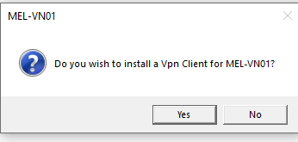

- Afterwards, check in VPN Connection – Connect MEL-VN01

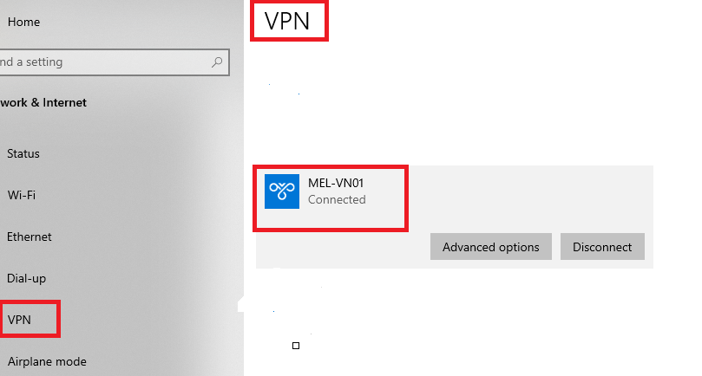

- Connection Status- Connect

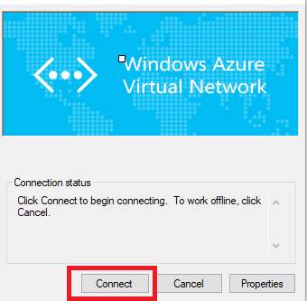

- Click on Continue
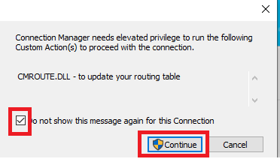

- Allow app to make changes to your device. Connection Manager- Yes

- Check VPN Connection- MEL-VN01 Connected

